TM



**CATAL!dST**

PRODUCT

**CATALOGUE**

**ltiMffiii9iW--.**

**Catabond FTA** specially

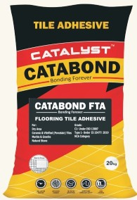formulated premium grade (C1) adhesive for large profile tiles and stones installations on floor.

Catabond FTA contains high grade polymers, silica, fillers, fibers and special additives.

Available in - **20kg**



**Catabond ITA** specially formulated premium grade (C2TE) adhesive for large profile tiles and stones installations on wet and dry areas. Catabond ITA contains high grade polymers, silica, fillers, fibers and special additives.

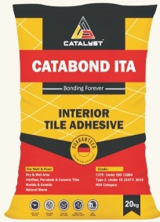Available in - **5kg, 10kg, 20kg**



**Catabond ETA** specially formulated premium grade (C2TE S1) flexible adhesive for absorbent/ nonabsorbent category tile/stone installations. Catabond ETA contains high grad polymers, silica, fillers, fibres and special additives.

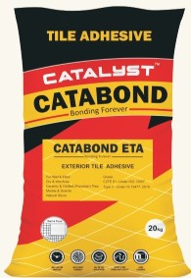Available in - **20kg**

# IEilHflJM!WII.

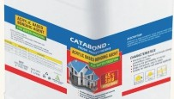**Catacreete** (Part B for ETA- Exterior Tile Adhesive) is Acrylic Latex emulsion with special additives. When Catacreete mix with Catabond Tile Adhesives, it increases the adhesion and bonding strength to the substrates,

improves plasticity and higher

resistance to water and humidity. Available in - **5Ltr**



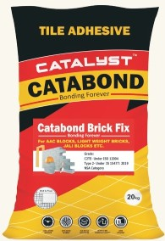**CATABOND BRICK FIX** is a high­

strength adhesive for quick and firm laying of AAC blocks with thin joints. Made of cement, graded sand, and blended with polymers, it provides high strength and water retention properties even when in thickness of 2-3 mm layer.

Available in - **20kg**

### CATAMIXTB

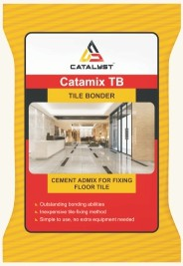Catamix TB Tile Bonder is a polymer additive which needs to be pre-mix with cement/ cement & sand and then should be mixed with water for installing tiles and natural stones using the traditional cement slurry over freshly laid leveling bed/ machan.

Available in - **200 grms**

### CATACLEAN-TC

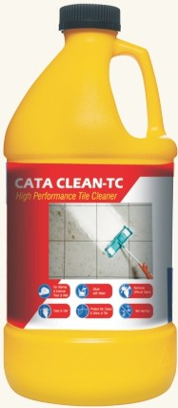**Cataclean-TC** is a high­ performance tile and ceramic cleaning liquid used to get rid of yellow spots, grimes, stains, oil, wax, and moss. The product is formulated to make it fit for use on tiling floors, walls, bathrooms, toilets and other tiling areas in domestic and commercial spaces.

Available in - **500 ml,1 Ltr, 5 Ltr**

### CATAGROUT

**Catagrout** is a cement-based tile joint filler that is suitable for use on the floor as well as wall tiles. It has a water-resistant formula and does a phenomenal job of filling the gaps effectively. Catagrout is designed for grouting purposes on different types of tiles such as grouting glazed, ceramic, porcelain, vitrified & fully vitrified tiles & natural stones.

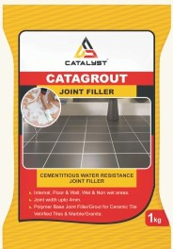

Available in -

**0.5kg, 1kg**

## CATAMIX- GA

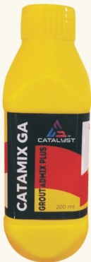**Catamix-GA** is the acrylic polymer based admix for use with Catagrout or other grouts to improve the performance and durability of the tile grout. It gives improved flexibility, strength, water and stain resistance that suitable for grouting wider joints.

Available in - **200 ml**

## CATABOND-SBR

**Catabond SBR** is a Styrene butadiene Rubber copolymer­ based product which is used in repairing mortars and concrete as an admixture and bonding agent to increase its water resistance and durability.

.

;.

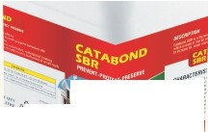

.

•

.a..

---

Available in - **1Ltr, 5Ltr, 20Ltr**

## CATABOND-AC

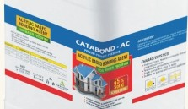**Catabond AC** is a single component, acrylic polymer based emulsion, designed as an admixture for cementitious mortars and screeds and as a bonding and curing agent for concrete, patch repairs and used for waterproofing.

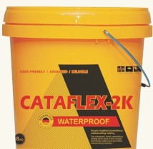Available in - **1Ltr, 5Ltr, 20Ltr**



**Cataflex-2K** is a two part acrylic modified cementitious coating. Cataflex-2K is a blend of cement, selected fillers, polymers and graded silica sand which is in the powder form. The liquid contains acrylic co­ polymers and wetting agents.

Available in - **8 Kg, 20 Kg**



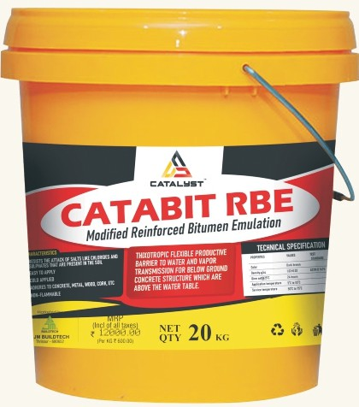**Catabit Rbe Bitumin Waterproof** is a thixotropic flexible protective barrier to water and vapor transmission for below ground concrete structure which are above the water table.

Available in - **10ltr, 20Ltr**



**Catabit Wb Bitumin Waterproof** is a thixotropic bitumen protective coating. The coating dries to form a black flexible protective film. The finished film forms a tough barrier to water and vapor transmission.

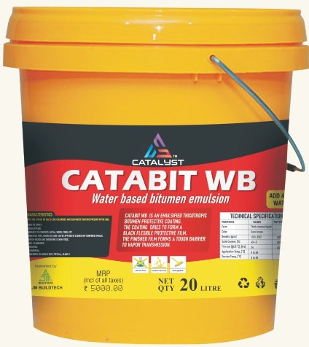Available in - **10ltr, 20Ltr**

* **!iiJ-itil1ti•!-iti•3;11)** ►

**Wallsealer WB** is a single component highly protective

treatment for concrete, masonry 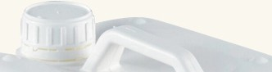

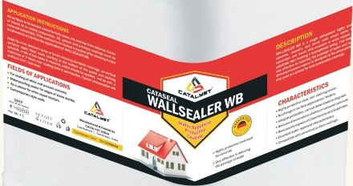and stone work which works by coating on these substrates and reacts with moisture or water vapour that is present in the substrate thus forming a hydrophobic lining.

Available in - **1Ltr, Sltr**

### CATASEAL PU-FLX

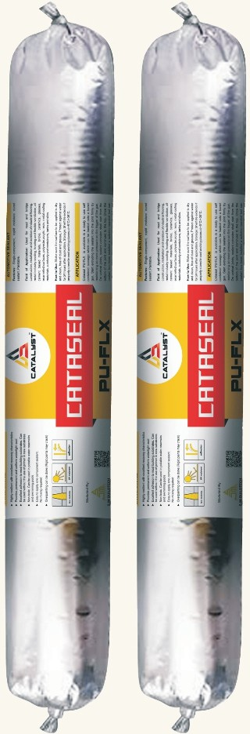**Cataseal PU-FLX** is a one-part low modulus high performance polyurethane sealant, which cures on absorption of atmospheric moisture to form a firm and flexible rubber watertight seal for moderate movement and control joints. CATASEAL PU-FLX can be used in both horizontal and vertical applications. The sealant has a Movement Accomodation Factor (MAF) of ±25%.

Available in - **600 ml**

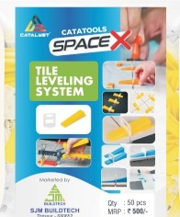

**Catamesh-Glass** fiber m fabrics combined with spe

esh cially face in a ons. stant the em,

•

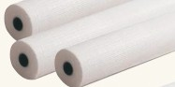designed mesh for sur treatments. It can be used wide range of applicati CATAMESH- an alkali resi fiberglass mesh, is used in WATERPROOFING syst

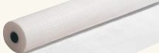embedded in the base coat to form a good reinforcement for the render.

Available in -

**150mm x 50mtr, 1 mtr x 50 mtr**



**Tile Spacer** is specially designed to create a uniform gap between tiles, this results in proper alignment throughout the tiling area. The spacers are available in different width sizes starting from 2mm width to 10 mm width. Packing-100nos

Available in - **2mm, 3mm, 4mm 5mm, 6mm, 8mm, 10mm.**

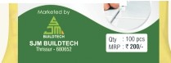

* .

/



**Tile Leveling Wedges** are designed for a faster and easier tile installation. Easy to operate, it enables to obtain perfectly flat floor and wall coverings, even in the most difficult cases, such as the installation of large format slabs. Just two components and one simple movement are enough to quickly and accurately prevent lippage between adjacent tiles. Additionally, no need to use spacers to create grout lines. Packing-SO nos.



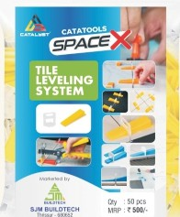**Tile Leveling Clips** are designed for a faster and easier tile installation. Easy to operate, it enables to obtain perfectly flat floor and wall coverings, even in the most difficult cases, such as the installation of large format slabs. Just two components and one simple movement are enough to quickly and accurately prevent lippage between adjacent tiles. Additionally, no need to use spacers to create grout lines. Packing-SO nos.

Available in - **2MM, 3MM, 4MM**

**1-WfJMm!I.**

#### Tile Leveling Reusable Jack

are made from high-density polyethylene so can be reused again and again. It is low-cost and easy to use product. REUSABLE JACK Work as T lock master leveling system, proleveling tile leveling system, and as tile leveling clips.

# IB IIH--,,

#### Tile Leveling Spinner & Clip

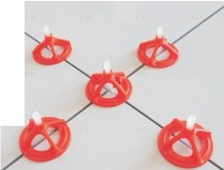has a free-spin design that allows the spinner to spin down the spacer screw with minimal effort. This allows installers to tighten the spinner with only one hand, which is especially useful for installing large format tile. When installation is finished simply kick *off* the caps to remove. The spinner caps are reusable for multiple jobs.

**ADDITIVES ADMIXTURES TILE ADHESIVE TILE GROUT**



**PRODUCT RANGE**

**INDUSTRIAL GROUT EPOXY & POLYURETHANE WATERPROOFING CONCRETE REPAIR SEALANTS**

**TOOLS**



**TM**

**CATALYST**

Catalyst India, Coimbatore-1, Tamilnadu, India

catalystindia.de [catalystindiachemicals@gmail.com](mailto:catalystindiachemicals@gmail.com)

**Customer Care** : **7012808844**